**Emerging Methods For Early Detection Of Forest Fires**

**Team ID : PNT2022TMID32061**

**Team Size : 4**

**Team Members**

**Ashok R 731619205002**

**Brethika R D 731619205006**

**Kabish S 731619205021**

**Krithick sanjay K 731619205027**

# INDEX

1. **INTRODUCTION 4**
   1. Project Overview
   2. Purpose
2. **LITERATURE SURVEY 5**
   1. Existing problem
   2. References
   3. Problem Statement Definition
3. **IDEATION & PROPOSED SOLUTION 7**
   1. Empathy Map Canvas
   2. Ideation & Brainstorming
   3. Proposed Solution
   4. Problem Solution fit
4. **REQUIREMENT ANALYSIS 12**
   1. Functional requirement
   2. Non-Functional requirements
5. **PROJECT DESIGN 16**
   1. Data Flow Diagrams
   2. Solution & Technical Architecture
   3. User Stories
6. **PROJECT PLANNING & SCHEDULING 19**
   1. Sprint Planning & Estimation
   2. Sprint Delivery Schedule
   3. Reports from JIRA
7. **CODING & SOLUTIONING (Explain the features added in the project along with code) 21**
   1. Feature 1
   2. Feature 2
8. **TESTING 28**
   1. Test Cases
   2. User Acceptance Testing

1. **RESULTS 30**
   1. Performance Metrics
2. **ADVANTAGES & DISADVANTAGES 35**
3. **CONCLUSION 36**
4. **FUTURE SCOPE 36**
5. **APPENDIX 37**

Source Code

GitHub & Project Demo Link

## Chapter-1

### INTRODUCTION

#### 1.1Project Overview

The ecological balance is maintained by the forests.It acts as an environment that enrich the diversity of various organisms.The motive of the project is to detect the forest fire as early as possible so that we can preserve the life of various species prevailing in it from the fire. Utilizing the currently available techniques of smokesensors put in the buildings, fire detection can be incredibly challenging. Due to their outdated technology and design, they are costly and slow. The use of artificial intelligence for identification and issuing alerts with video from CCTV footages is critically examined in this study. For this project, a self-built dataset of videoframes with fire is used. The data is then preprocessed and a machine learning model is built using CNN. The dataset's test set is used as input to verify the method, and experiments are recorded. The goal of the project is to create a machine that is both affordable and very precise and can be applied to practically any fire detecting situation.

#### 1.2 Purpose

One of the key elements in keeping the ecological in balance is forests. When a fire breaks out in a forest, it can be very dangerous. However, a forest fire is typically discovered after it has spread across a significant area. It might not always be able to put out the fire. As a result, environmental impact is worse than anticipated. The environment suffers because of the forest fire's large-scale carbon dioxide (CO2) emissions. It would result in the global extinction of rare species. Additionally, it may have an effect on the weather, which may lead to serious problems like earthquakes, excessive rain, floods, and so forth.The forest is a big surface area covered with trees, tonnes of dried leaves, woodlands, and other things. When the fire first ignites, these substances help it grow. Fire might start for a variety of causes, including smoking, fireworks-themed events, or high summer temperatures. Once a fire starts, it won't stop until it has entirely burned itself out. When the fire is noticed as early as feasible, the damage and the cost associated with identifying it due to a forest fire can be minimised. Therefore, in this case, fire detection is crucial. A good effect can be had by locating the fire's specific location and notifying the fire authorities as soon as the fire occurs.Thus it is crucial to implement a system to identify fires as soon as possible.

## Chapter 2

### LITERATURE SURVEY

#### 2.1 Existing problem

Smoke alarms and heat alarms are being used to detect fires. One module is not enough to monitor all of the potential fire prone areas, which is the fundamental drawback of smoke sensor alarms and heat sensor alarms. The only way to avoid a fire is to exercise caution at all times. Even if they are installed in every nook and cranny, it simply is not enough to constantly produce an efficient output. As the number of smoke sensors required rises, the price will rise by a factor of multiples. Within seconds of an accident or a fire, the suggested system can generate reliable and highly accurate alerts. One piece of software powers the entire surveillance network, which lowers costs. Data scientists and machine learning experts are actively conducting research in this area.

#### 2.2 References

1. Official webpage of the European Forest Fire Information System at: http://effis.jrc.ec.europa.eu/
2. Official webpage of the Copernicus Earth Observation Programme at: http://www.copernicus.eu
3. Forest Fires in Europe, Middle East and North Africa 2016, JRC Science for policy report, BN 978-92-79-71292-0, ISSN 1831-9424, doi:10.2760/17690, availabe at:

http://effis.jrc.ec.europa.eu/media/cms_page_media/40/Forest_fires_i n_Europe_Middle_east_and_North_Africa_2016_final_pdf_JZU7He

L.pdf

1. The 2018 Attica wildfires Wikipedia webpage available at: https://en.wikipedia.org/wiki/2018_Attica_wildfires
2. László Földi and Rajmund Kuti, Characteristics of Forest Fires and their Impact on the Environment, Academic and Applied Research in

Military and Public Management Science (AARMS), Vol. 15, No. 1,

2016, pp. 5–17, ISSN 2064-0021;

1. https://www.firedex.com
2. Wolfgang Jendsch, Aerial Firefighting, Schiffer Publishing, 352 pp,

ISBN 9780764330681

1. Chi Yuan, Youmin Zhang and Zhixiang Liu, A Survey on

Technologies for Automatic Forest Fire Monitoring, Detection and

Fighting Using UAVs and Remote Sensing Techniques, Canadian

Journal of Forest Research, doi: 10.1139/cjfr-2014-0347

1. W. Krüll, R. Tobera, I. Willms, H. Essen and N. V. Wahl, Early Forest

Fire Detection and Verification Using Optical Smoke, Gas and

Microwave Sensors, Procedia Engineering vol. 45, pp. 584-594, 2012 [10] Project SFEDA page at: http://www.interreg-balkanmed.eu/approved- project/22/

1. V. C. Moulianitis, G. Thanellas, N. Xanthopoulos, N. A. Aspragathos,

Evaluation of UAV based schemes for forest fire monitoring, 27th

International Conference on Robotics in Alpe-Adria-Danube Region,

RAAD 2018

1. Official webpage of the ALTi Transition VTOL UAV at: https://www.altiuas.com/transition/
2. Official webpage of the DJI Matrice 600 Pro UAV at: https://www.dji.com/matrice600-pro
3. Official webpage of the DJI Matrice 200 series of UAVs at: https://www.dji.com/matrice-200-series
4. Official webpage of Movidius at: https://www.movidius.com [16] Official webpage of the IMST iC880A LoRaWAN concentrator at: https://wireless-solutions.de/products/long-range-radio/ic880a.html

#### 2.3 Problem Statement Definition

Forest fires result in a wide range of negative effects, including the destruction of wildlife habitat, the extinction of plants and animals, the destruction of nutrient-rich top soil, the reduction of forest cover, the loss of valuable timber resources, the ozone layer being destroyed, the loss of livelihood for tribal and poor people, the acceleration of global warming, the increase in atmospheric carbon dioxide concentration, the degradation of catchment areas, the loss of biodiversity, the spread of disease, etc. Thus, Develop a system to detect forest fires at the earliest stage as possible using the lastest technologies.

## Chapter 3

### IDEATION & PROPOSED SOLUTION

#### 3.1 Empathy Map Canvas

An empathy map is a simple, easy-to-digest visual that captures knowledge about a user’s behaviors and attitudes. It is a useful tool to help teams better understand their users. Creating an effective solution requires understanding the true problem and the person who is experiencing it. The exercise of creating the map helps participants consider things from the user’s perspective along with his or her goals and challenges.

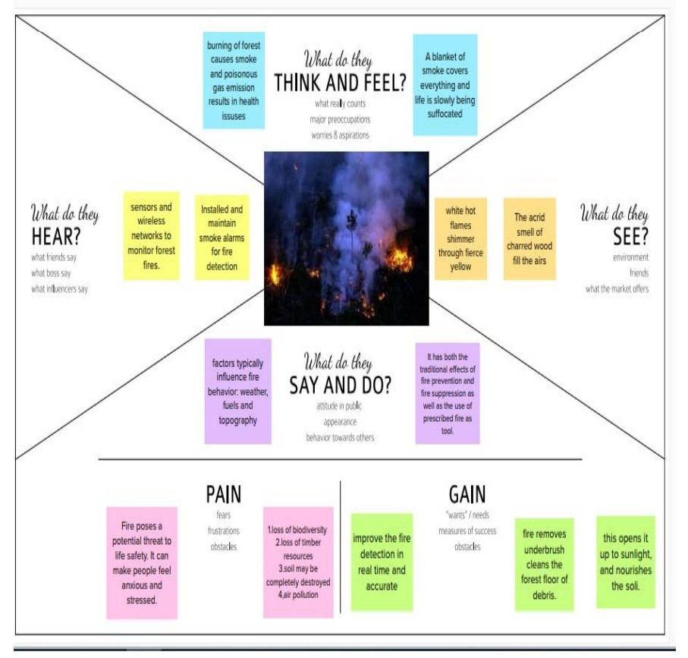

#### 3.2 Ideation And Brainstorming

Brainstorming provides a free and open environment that encourages everyone within a team to participate in the creative thinking process that leads to problem solving. Prioritizing volume over value, out-of-the-box ideas are welcome and built upon, and all participants are encouraged to collaborate, helping each other develop a rich amount of creative solutions.

##### Brainstorm, Idea Listing and Grouping

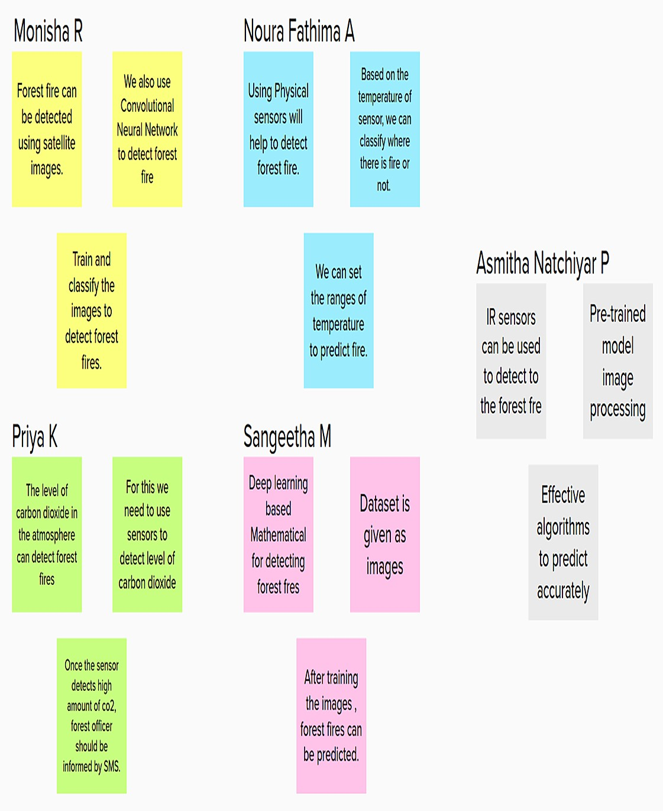

**Idea Prioritization**

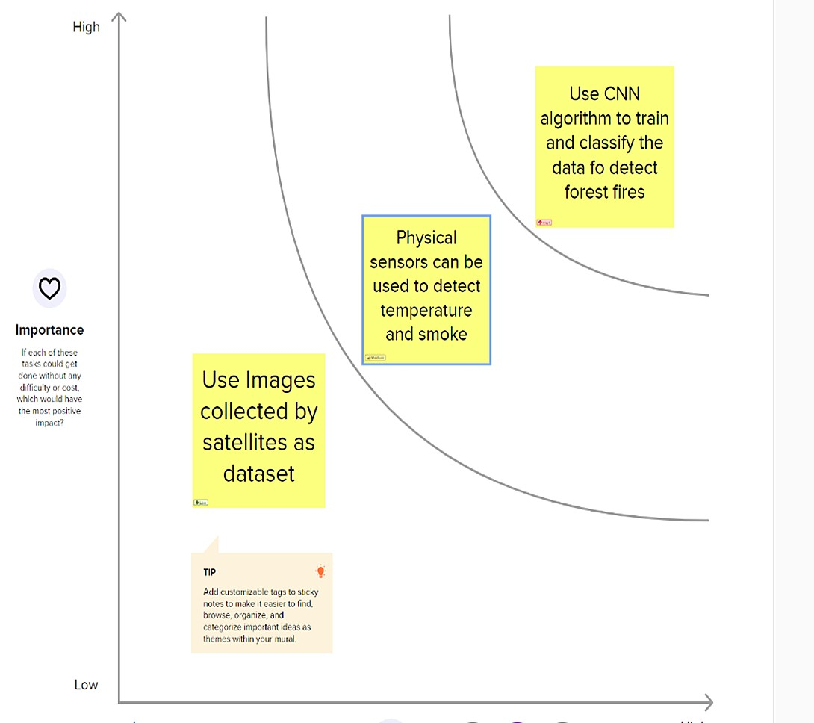

#### 3.3 Proposed Solution

|  |  |  |
| --- | --- | --- |
| **S.No.** | **Parameter** | **Description** |
| 1. | Problem  Statement (Problem to be solved) | Forest fires are a major environmental issue, creating economic and ecological damage while endangering human lives.  It is difficult to predict and detect Forest Fire in a sparsely populated forest area  So it is necessary to Detect forest fires in an early stage to avoid massive damage. |
| 2. | Idea / Solution description | Identifying huge forest fires in real-time utilizing AI algorithms with camera and satellite footage.  The systems then notify dispatchers and local authorities about the new ignition |
| 3. | Novelty /  Uniqueness | Convolutional Neural Network system allows us to deliver information more quickly and accurately. It is possible to deploy a comprehensive coverage, which is nearly impossible |
| 4. | Social  Impact /  Customer  Satisfaction | Monitoring of the potential danger regions and early identification of fire can greatly minimize the response time, as well as potential damage and frightening expenses, while also saving many lives. |
| 5. | Business  Model  (Revenue Model) | The application is based on Subscription Model |
| 6. | Scalability of the Solution | Can monitor different places simultaneously and can detect fire accurately.  Despite the physical distance between resources and users, its regionally scalable system maintains its usability and utility; |

#### 3.4 Problem Solution Fit

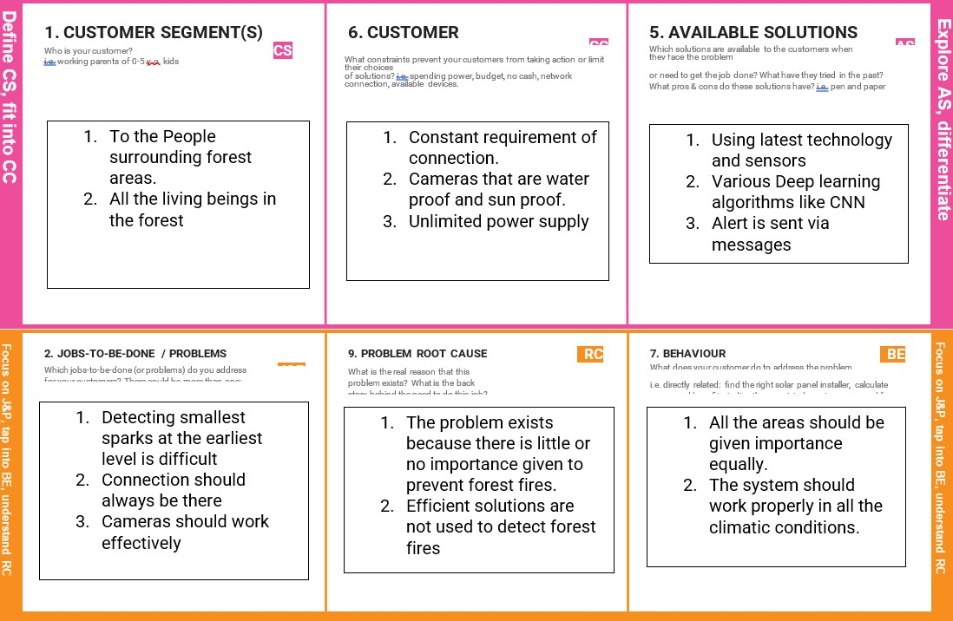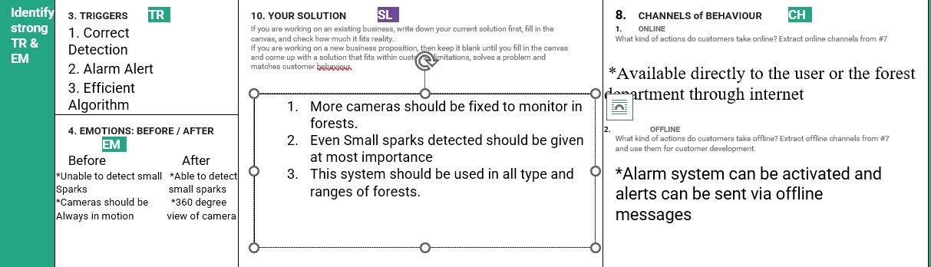

**Chapter 4**

**REQUIREMENT ANALYSIS**

#### 4.1 Functional Requirements

Following are the functional requirements of the proposed solution.

|  |  |  |
| --- | --- | --- |
| **FR No.** | **Functional Requirement**  **(Epic)** | **Sub Requirement (Story / Sub-Task)** |
| FR-1 | Monitoring the smoke ,wind speed,CO2 and temperature using sensors | * Fire can be detected by using the amount of smoke. The smoke sensors are used to measure the amount of smoke from the fire, and it could be compared with a threshold value and if it is beyond that value. * The wind speed is calculated by the wind sensor nodes, which are manually placed in the forest. * When forest fires burn, they emit large volumes of carbon dioxide gas (CO2); you can use a network , CO2 and temperature sensors for forest fire detection. |
| FR-2 | Unmanned aerial vehicle(UAV) | The forest fires can be detected by visionbased fire detection systems which can be mounted to an unmanned aerial vehicle (UAVs) for strategically scanning acreage of fire prone areas. |
| FR-3 | Image processing by  CCTV cameras | The cameras rotate continuously, scan the countryside with color, monochrome and near-infrared detectors. A feature-based AI algorithm uses an artificial neural network to scan the images for the telltale heat and smoke signature of wildfires. Under the right conditions, it can see as far as 40 miles away |
| FR-4 | Data processing using  Real time algorithm | The algorithm processes the data in real time on dedicated servers on site.It uses a cloud-based deep learning AI to detect and verify wildfire events in real time, drawing from satellite imagery and historical data. |
| FR-5 | Light detection and ranging (LIDAR) | The system is used for the forest fire detection with the help of neural network .LIDAR is mainly used in the environmental and atmospheric studies. A lidar contains a photo detector, radiation emitter, signal receiver and signal processing hardware and software. |
| FR-6 | Localization of fire | It use GPS to **track their location** as they can sends these location details along with the data such as measurements of temperature to cloud (or) other cloud based server. |

**4.2 Non-functional Requirements:**

Following are the non-functional requirements of the proposed solution.

|  |  |  |
| --- | --- | --- |
| **FR No.** | **Non-Functional**  **Requirement** | **Description** |
| NFR-1 | **Usability** | AI devices with machine learning verifies that usability is a special and important perspective to analyze user requirements, which can further improve the design quality. |
| NFR-2 | **Security** | * Powerful CCTV and HD cameras are used. * Monitors 24/7 * IR flame detectors are used * Avoid intentional acts of arson |
| NFR-3 | **Reliability** | A real-time and reliable fire detection method for an early warning system is required so that an immediate response to an incident can be made effective. |
| NFR-4 | **Performance** | The system is designed for monitor the causing factors of forest fires such as temperature, humidity , air pressure level,oxygen and Carbon dioxide on the surface of air by using sensors.  The CCTV cameras is used for image processing and detecting the forest fire.  The GPS is used to track the location of forest fire. |
| NFR-5 | **Availability** | By developing more advanced system by integrating wireless sensors with CCTV for added protection and precision. The algorithm shows great promise in adapting to various environment. |
| NFR-6 | **Scalability** | By detecting the forest fire we can reduce air pollution, landslides,soil erosion by protecting strong rooted trees,the emission of CO2 into the air during fire,No loss of life and resources. |

## Chapter 5

### PROJECT DESIGN

#### 5.1 Data Flow Diagrams

A Data Flow Diagram (DFD) is a traditional visual representation of the information flows within a system. A neat and clear DFD can depict the right amount of the system requirement graphically. It shows how data enters and leaves the system, what changes the information, and where data is stored.

**FLOW:**

* It is difficult to predict and detect Forest Fire in a sparsely populated forest area.
* It is more difficult if the prediction is done using ground-based methods like Camera or Video-Based approach.
* Satellites can be an important source of data prior to and also during the Fire due to its reliability and efficiency.
* The various real-time forest fire detection and prediction approaches, with the goal of informing the local fire authorities.
* If the fire is not detected it will send the result to the frame camera. if the forest fire will detected the alert will go to the video feed frame camera.

##### DIAGRAM

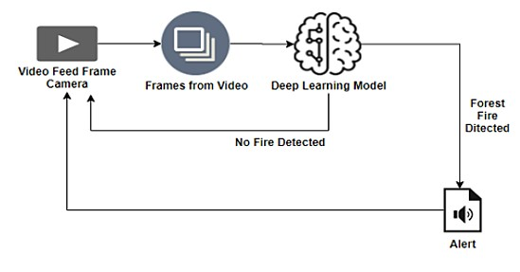

**5.2 Solution & Technical Architecture:**

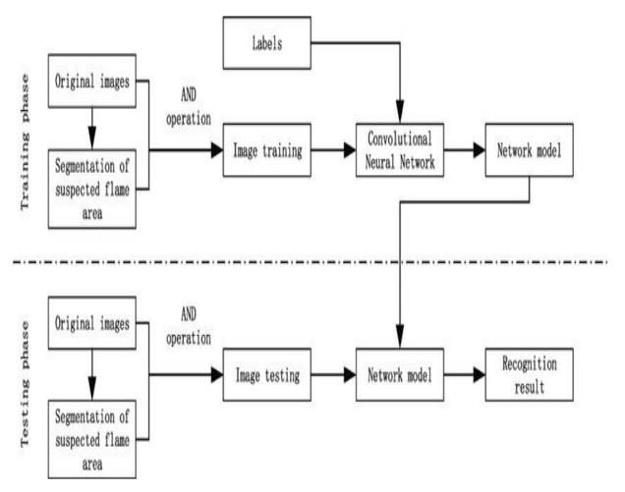

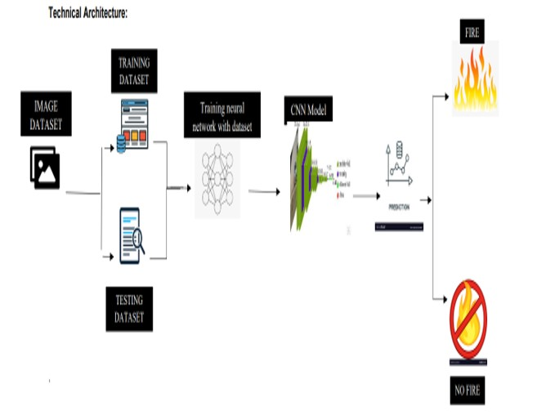

#### 5.3 User Stories

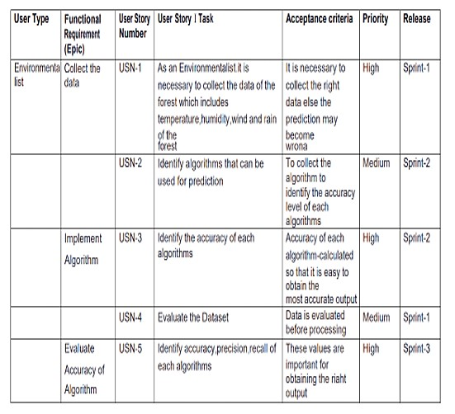

## Chapter 6

**PROJECT PLANNING & SCHEDULING**

### 6.1 Sprint Planning & Estimation

|  |  |  |  |  |  |
| --- | --- | --- | --- | --- | --- |
| **Sprint** | **Functional**  **Requirement**  **(Epic)** | **User**  **Story**  **Number** | **User Story / Task** | **Story Points** | **Priority** |
| Sprint-1 | Registration | USN-1 | I can sign up for the application as a user by providing my email address, a password, and a password confirmation. | 20 | High |
| Sprint-1 |  | USN-2 | Once I've signed up to use the application, I, as a user,will receive a confirmation email. | 20 | Medium |
| Sprint-2 | Input | USN-3 | The database receives information each time a fire is discovered. | 20 | High |
| Sprint-2 |  | USN-4 | The warning system is turned on when there is a wildfire. | 20 | High |
| Sprint-3 | Output | USN-5 | Additionally, the alarm informed the relevant departments that a wildfire had started. | 20 | High |
| Sprint-4 | Action | USN-6 | The necessary steps will be taken to control the erupted wildfire by getting there as quickly as possible with the aid of detecting systems. | 20 | High |

### 6.2 Sprint Delivery Schedule

|  |  |  |  |  |  |  |
| --- | --- | --- | --- | --- | --- | --- |
| **Sprint** | **Total**  **Story Poin**  **ts** | **Duration** | **Sprint**  **Start Date** | **Sprint**  **End Date**  **(Planned)** | **Story**  **Points Comple**  **ted (as on Planne dEnd Date)** | **Sprint**  **ReleaseDa te (Actual)** |
| Sprint-1 | 20 | 6 Days | 24 Oct  2022 | 29 Oct 2022 | 20 | 29 Oct 2022 |
| Sprint-2 | 20 | 6 Days | 31 Oct  2022 | 05 Nov 2022 | 20 | 05 Nov 2022 |
| Sprint-3 | 20 | 6 Days | 07  Nov  2022 | 12 Nov 2022 | 20 | 12 Nov 2022 |
| Sprint-4 | 20 | 6 Days | 14  Nov  2022 | 19 Nov 2022 | 20 | 19 Nov 2022 |

### 6.3 Reports from JIRA

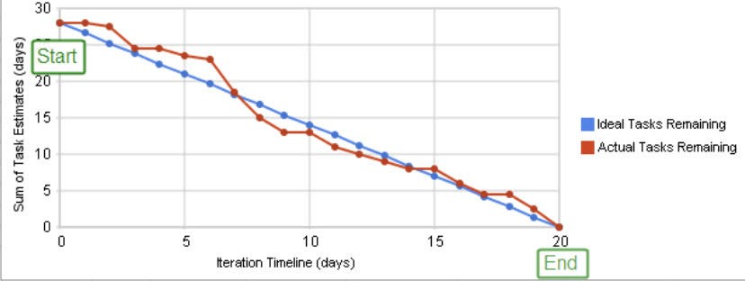

## Chapter 7

### CODING & SOLUTIONING

***7.1 Feature 1***

**1. Preprocessing the dataset which consists of two classes of data(fire,no fire).**

#### Image Preprocessing

***#1.Importing the ImageDataGenerator Library*** **import** numpy **as** np***7.***

**import** keras **from** sklearn.model_selection **import** train_test_split **from** keras.models **import** Sequential, load_model **from** keras.preprocessing.image **import** ImageDataGenerator **from** keras.callbacks **import** ModelCheckpoint, EarlyStopping, TensorBoard **from** keras.callbacks **import** ReduceLROnPlateau

**from** keras.layers **import** Conv2D, Dropout, Dense, Flatten, MaxPooling2D, SeparableConv2D, Activation, BatchNormalization **import** matplotlib.pyplot **as** plt **import** time **import** os

**import** tensorflow **as** tf

***#2.Define parameters for ImageDataGenerator Class*** train_datagen**=**ImageDataGenerator(rescale**=**1.**/**255,

shear_range**=**0.2,

rotation_range**=**180,

zoom_range**=**0.2,

horizontal_flip**=True**)

test_datagen**=**ImageDataGenerator(rescale**=**1.**/**255)

##### *#3.Applying ImageDataGenerator Functionality to Trainset and Testset*

#*a. For Dataset* x_dataset =train_datagen.flow_from_directory(r"/content/drive/MyDrive/ForestDataset/forest_fire",target_size = (128,128), class_mode = "binary",batch_size=32)

###### #b. For Trainset

x_train =train_datagen.flow_from_directory(r"/content/drive/MyDrive/ForestDataset/forest_fire/Training and Validation",target_size = (128,128), class_mode = "binary",batch_size=32) # *c. For Testset*

x_test =test_datagen.flow_from_directory(r"/content/drive/MyDrive/ForestDataset/forest_fire/Testing",target_size = (128,128), class_mode = "binary", batch_size=32) x_train.class_indices

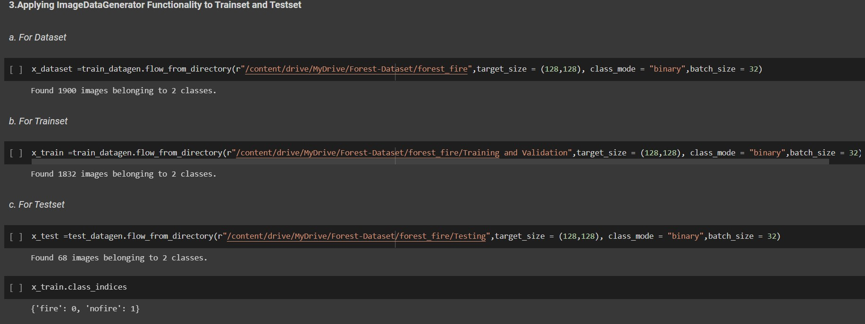

**2.Building up a sequential model to train the dataset.**

##### *# 1.Importing the Model Building Libraries*

#Importing model libraries

from tensorflow.keras.models import Sequential from tensorflow.keras.layers import Dense from tensorflow.keras.layers import Convolution2D from tensorflow.keras.layers import MaxPooling2D from tensorflow.keras.layers import Flatten

import warnings

warnings.filterwarnings('ignore')

***# 2.Initializing the Model*** model=Sequential()

***# 3.Adding CNN Layers*** # a. Adding Convolutional layer

model.add(Convolution2D(32,(3,3),input_shape=(128,128,3),activation='relu'))

# b. Adding Pooling Layer

model.add(MaxPooling2D(pool_size=(2,2)))

# c. Adding Flatten Layer

model.add(Flatten()) #Model Summary model.summary()

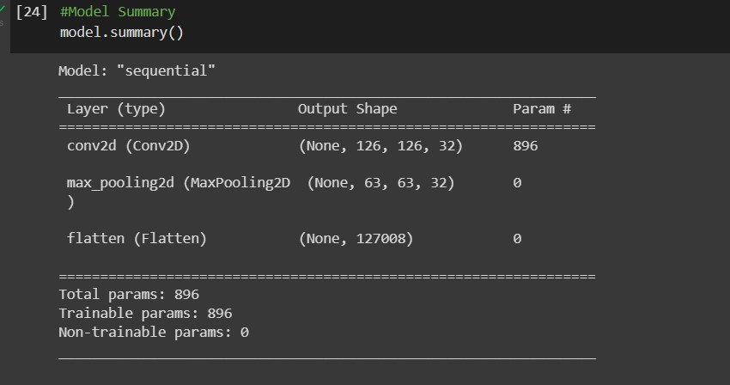

**3. Prediction of data.**

***# Predictions*** pred = model.predict(x) pred = np.round(pred) pred

def predictImage(filename):

img1=image.load_img(filename,target_size=(128,128))

plt.imshow(img1)

y=image.img_to_array(img1)

x=np.expand_dims(y,axis=0)

val=model.predict(x)

print(val)

if val==0:

plt.xlabel(" No Fire",fontsize=30)

elif val==1:

plt.xlabel("Fire",fontsize=30) predictImage("/content/drive/MyDrive/ForestDataset/forest_fire/Testing/fire/abc173.jpg") plt.xlabel("fire",fontsize=30) predictImage('/content/drive/MyDrive/ForestDataset/forest_fire/Testing/nofire/abc377.jpg') plt.xlabel(" NO fire",fontsize=30)

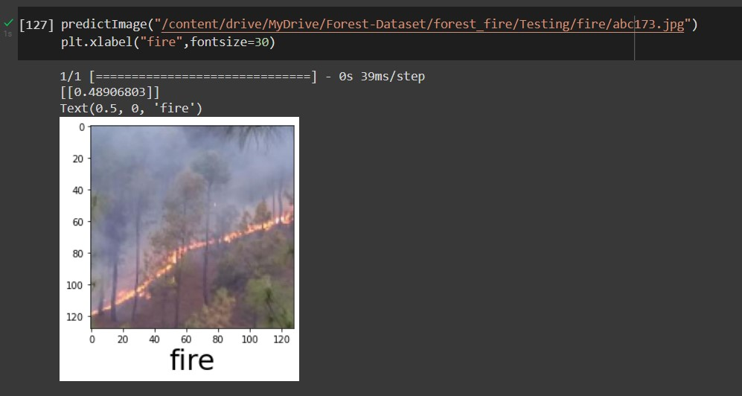

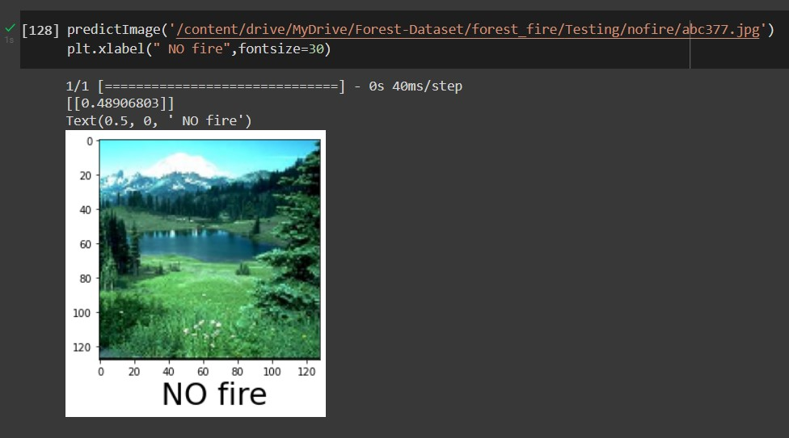

#### 7.2 Feature 2

##### 1.Creation of twilio account

To send an outgoing SMS message from your Twilio account you’ll need to make an

HTTP POST to Twilio's Message resource.

Twilio's Python library helps you to create a new instance of the Message resource, specifying the To, From, and Body parameters of your message.

Replace the placeholder values for account_sid and auth_token with your unique values.

You can find these in your Twilio console.

You’ll tell Twilio which phone number to use to send this message by replacing the from_ number with the Twilio phone number you purchased earlier.

Next, specify yourself as the message recipient by replacing the to number with your mobile phone number. Both of these parameters must use [E.164](https://www.twilio.com/docs/glossary/what-e164) formatting (+ and a country code, e.g., +16175551212)

We also include the body parameter, which contains the content of the SMS we’re going to send.

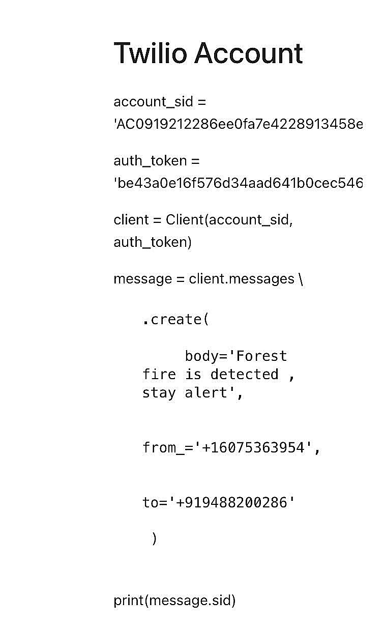

**2. Sending SMS alert**

pip install twilio pip install playsound

***#import opencv librariy*** import cv2 ***#import numpy*** import numpy as np

*#import image function from keras* from keras.preprocessing import image *#import load_model from keras* from keras.models import load_model ***#import client from twilio API*** from twilio.rest import Client *#imort playsound package* from playsound import playsound

***#load the saved model*** model **=** load_model(r'/content/drive/MyDrive/archive (1)/forest1.h5')

***#define video***

video **=** cv2**.**VideoCapture('/content/Fighting Fire with Fire _ Explained in 30

Seconds.mp4')

***#define the features*** name **=** ['forest','with forest']

account_sid **=** ' AC0919212286ee0fa7e4228913458e863f' auth_token **=** ' be43a0e16f576d34aad641b0cec546ef ' client **=** Client(account_sid, auth_token)

message **=** client**.**messages \

**.**create(

body**=**'Forest fire is detected , stay alert',

from_**=**'+16075363954',

to**=**'+919488200286'

)

print(message**.**sid)

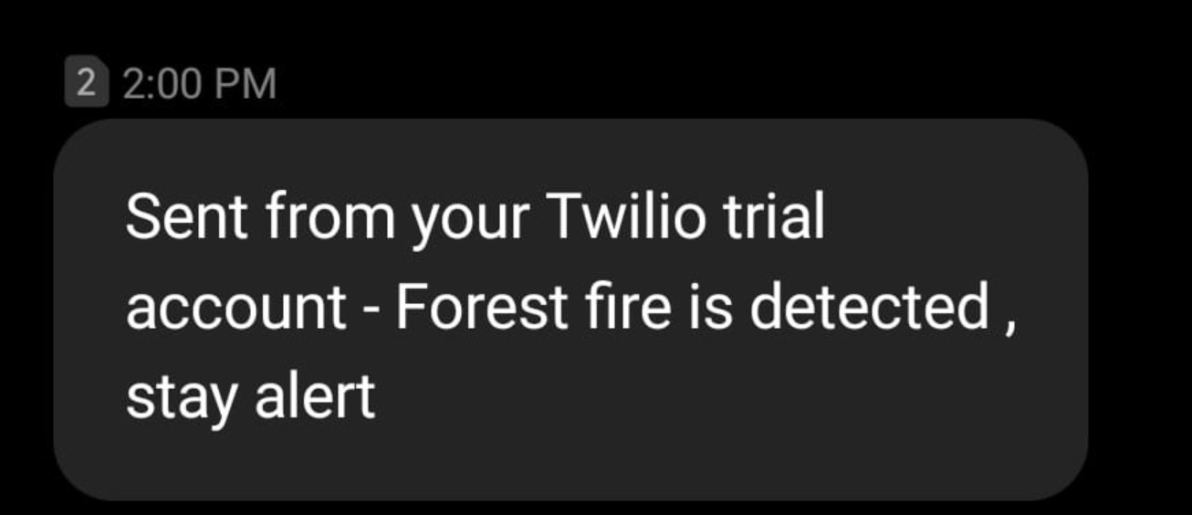

## Chapter 8

### TESTING

#### 8.1 Test Cases

Panel switches and keypads : TEST the operation of each control.

Visual indicators : TEST the operation of each visual indicator and alphanumeric displays.

Battery: MEASURE system quiescent and maximum alarm currents in accordance with Appendix . Calculate the required battery capacity and CHECK the nominal capacity of the installed batteries is not less than the calculated capacity.

Verify that the measured currents are the same as recorded in the baseline data.

#### 8.2 User Acceptance Testing

##### 1.Purpose of Document

The purpose of this document is to briefly explain the test coverage and open issues of the project at the time of the release to User Acceptance Testing (UAT).

##### 2.Defect Analysis

This report shows the number of resolved or closed bugs at each severity level, and how they were resolved

|  |  |  |  |  |  |
| --- | --- | --- | --- | --- | --- |
| **Resolution** | **Severity 1** | **Severity 2** | **Severity 3** | **Severity 4** | **Subtotal** |
| By Design | 9 | 5 | 1 | 2 | 17 |
| Duplicate | 1 | 0 | 2 | 0 | 3 |
| External | 3 | 3 | 0 | 1 | 7 |
| Fixed | 10 | 2 | 3 | 20 | 35 |
| Not  Reproduced | 0 | 0 | 1 | 0 | 1 |
| Skipped | 0 | 0 | 1 | 1 | 2 |
| Won't Fix | 0 | 4 | 2 | 1 | 7 |
| Totals | 13 | 15 | 10 | 25 | 7  2 |

##### 3.Test Case Analysis

This report shows the number of test cases that have passed, failed, and untested

|  |  |  |  |  |
| --- | --- | --- | --- | --- |
| **Section** | **Total Cases** | **Not Tested** | **Fail** | **Pass** |
| Print Engine | 7 | 0 | 0 | 7 |
| Client Application | 53 | 0 | 0 | 53 |
| Security | 2 | 0 | 0 | 2 |
| Outsource  Shipping | 4 | 0 | 0 | 4 |
| Exception  Reporting | 7 | 0 | 0 | 7 |
| Final Report  Output | 3 | 0 | 0 | 3 |
| Version Control | 1 | 0 | 0 | 1 |

## Chapter 9

### RESULTS

#### 9.1 Performance Metrics

##### 1.Training the Model

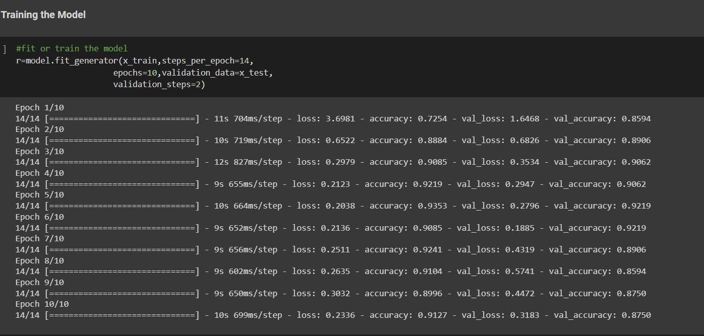

##### 2.Loss or No loss

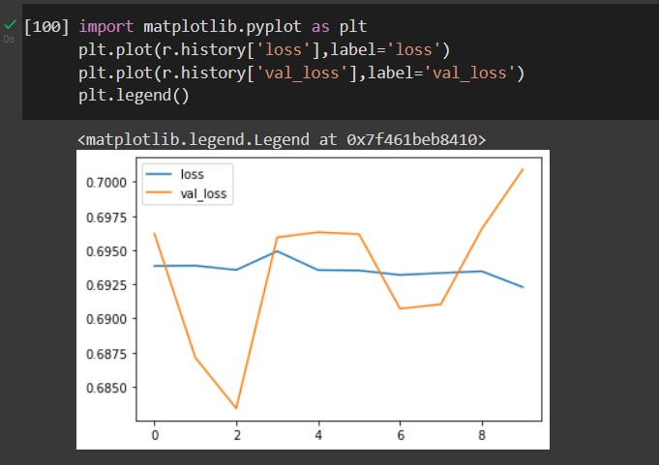

##### 3.Accuracy Value

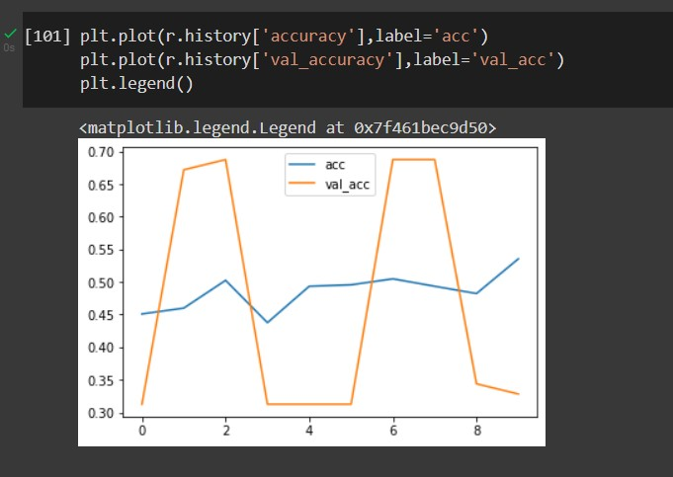

##### 4.Confusion matrix

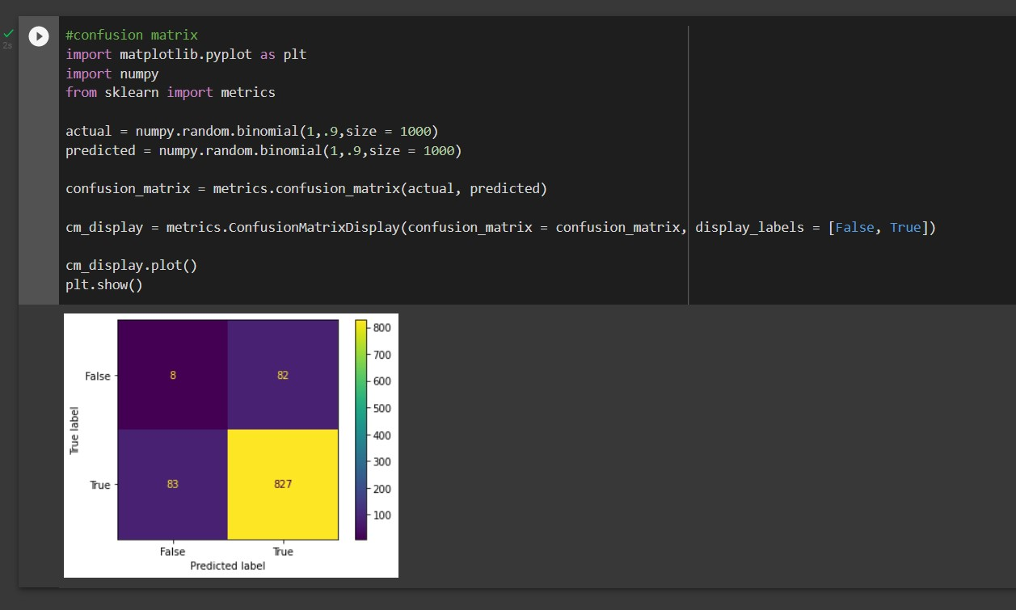

##### 5.Predictions





## Chapter 10

### ADVANTAGES & DISADVANTAGES

**ADVANTAGES:**

* The proposed system detects the forest fire at a faster rate compared to existing system. It has enhanced data collection feature.
* The major aspect is that it reduces false alarm and also has accuracy due to various sensors present.
* It minimizes the human effort as it works automatically.
* This is very affordable due to which can be easily accessed.
* The main objective of our project is to receive an alert message through an app to the respective user.
* The arrangement is fire-proof and can withstand high temperatures, rugged, reliable, cost-effective, and easy to install.
* It is also easy to decode the data from satellite at the ground station and no experts are required to understand or decode the data from the satellite.
* All the components like temperature sensor and the GPS are easy to interface.
* The approximate value of temperature and the GPS co-ordinates are obtained. Since we are using wireless sensing networks, the attenuation during the transmission of the signal or the data is minimised.
* It is More Reliable

**DISADVANTAGES:**

* The electrical interference diminishes the effectiveness of radio receiver.
* The main drawback is that it has less coverage range areas.
* Even a small fault would cause the whole system to fail.

## Chapter 11

### CONCLUSION

The proposed system for forest fire detection using wireless sensor networks and machine learning was found to be an effective method for fire detection in forests that provides more accurate results. Here, to obtain a more accurate outcome within the lowest latency, the analysis should take place continuously and camera monitoring should be effectively done. This system is well developed to fit any weather condition, climatic condition, or area, . In the case of node deployment, cameras can be mounted at any place in the forest even with good connectivity and built-in network infrastructure. IR frame sensors are used to enhance efficiency of the system. A unique feature that sends alert messages to the concerned authorities when fire is detected is also added. Thus, By detecting the forest fire we can reduce air pollution, landslides,soil erosion by protecting strong rooted trees,and the emission of CO2 into the air during fire causing no loss of life and resources.

## Chapter 12

### FUTURE SCOPE

* Right now we have designed the project for control of two devices but it can be designed for more numbers of devices.
* It can be further expanded with a voice interactive system facility.
* A feedback system can also be included which provides the state of device to the remote users.

## Chapter 13

### APPENDIX

#### Source Code

##### #Download the Dataset

pwd

*#Load the Image Dataset* from google.colab import drive drive.mount('/content/drive')

*# call load_data with allow_pickle implicitly set to true* import numpy as np

data **=** np**.**load('/content/drive/My Drive/Forest-Dataset/Dataset.zip', allow_pickle**=True**) print('data loaded') cd **//**content**/**drive**/**MyDrive**/**Forest**-**Dataset

*#Unzip the Dataset*

!unzip Dataset**.**zip

###### #Image Preprocessing

***#1.Importing the ImageDataGenerator Library*** **import** numpy **as** np **import** keras **from** sklearn.model_selection **import** train_test_split **from** keras.models **import** Sequential, load_model **from** keras.preprocessing.image **import** ImageDataGenerator **from** keras.callbacks **import** ModelCheckpoint, EarlyStopping, TensorBoard **from** keras.callbacks **import** ReduceLROnPlateau

**from** keras.layers **import** Conv2D, Dropout, Dense, Flatten, MaxPooling2D, SeparableConv2D, Activation, BatchNormalization **import** matplotlib.pyplot **as** plt **import** time **import** os

**import** tensorflow **as** tf

***#2.Define parameters for ImageDataGenerator Class*** train_datagen**=**ImageDataGenerator(rescale**=**1.**/**255,

shear_range**=**0.2,

rotation_range**=**180,

zoom_range**=**0.2,

horizontal_flip**=True**)

test_datagen**=**ImageDataGenerator(rescale**=**1.**/**255)

###### #3.Applying ImageDataGenerator Functionality to Trainset and Testset

#a. For Dataset

x_dataset =train_datagen.flow_from_directory(r"/content/drive/MyDrive/ForestDataset/forest_fire",target_size = (128,128), class_mode = "binary",batch_size=32)

#b. For Trainset

x_train =train_datagen.flow_from_directory(r"/content/drive/MyDrive/ForestDataset/forest_fire/Training and Validation",target_size = (128,128), class_mode = "binary",batch_size=32) # *c. For Testset*

x_test =test_datagen.flow_from_directory(r"/content/drive/MyDrive/ForestDataset/forest_fire/Testing",target_size = (128,128), class_mode = "binary", batch_size=32) x_train.class_indices ***# Model Building***

###### # 1.Importing the Model Building Libraries

#Importing model libraries

from tensorflow.keras.models import Sequential from tensorflow.keras.layers import Dense from tensorflow.keras.layers import Convolution2D from tensorflow.keras.layers import MaxPooling2D from tensorflow.keras.layers import Flatten

import warnings

warnings.filterwarnings('ignore') ***# 2.Initializing the Model*** model=Sequential()

***# 3.Adding CNN Layers*** # a. Adding Convolutional layer

model.add(Convolution2D(32,(3,3),input_shape=(128,128,3),activation='relu')) # b. Adding Pooling Layer

model.add(MaxPooling2D(pool_size=(2,2)))

# c. Adding Flatten Layer model.add(Flatten()) #Model Summary model.summary() ***# 4.Adding Dense Layers***

#a. Adding Hidden layers #model.add(Dense(300,activation='relu')) model.add(Dense(150,activation='relu')) #b. Adding Output layer model.add(Dense(1,activation='sigmoid')) ***# 5.Configuring the Learning Process***

model.compile(loss='binary_crossentropy',

optimizer='adam',

metrics=['accuracy'])

###### # 6.Training the Model #fit or train the model

r=model.fit_generator(x_train,steps_per_epoch=14,

epochs=10,validation_data=x_test,

validation_steps=2) #plotting loss value import matplotlib.pyplot as plt plt.plot(r.history['loss'],label='loss') plt.plot(r.history['val_loss'],label='val_loss')

plt.legend() #plotting accuracy value plt.plot(r.history['accuracy'],label='acc') plt.plot(r.history['val_accuracy'],label='val_acc') plt.legend() ***# 7.Save the Model*** model.save("forest1.h5") ls forest_fire/

###### # 8.Test The Model import numpy as np

from tensorflow.keras.models import load_model from tensorflow.keras.preprocessing import image import cv2

#load the model model=load_model('forest1.h5') img=image.load_img('/content/drive/MyDrive/ForestDataset/forest_fire/Testing/fire/abc169.jpg') img img=image.load_img('/content/drive/MyDrive/Forest-

Dataset/forest_fire/Testing/fire/abc169.jpg',target_size=(128,128)) img

x=image.img_to_array(img) x x=np.expand_dims(x,axis=0) x y=np.argmax(model.predict(x),axis=1) y x_train.class_indices index=['fire','nofire'] index[y[0]] #Testing image 1 img=image.load_img('/content/drive/MyDrive/Forest-

Dataset/forest_fire/Testing/fire/abc183.jpg',target_size=(128,128))

x=image.img_to_array(img) x=np.expand_dims(x,axis=0)

index=['fire','nofire']

print('Fire')

img

**#Testing image 2** img=image.load_img('/content/drive/MyDrive/Forest-

Dataset/forest_fire/Testing/nofire/abc337.jpg',target_size=(128,128)) x=image.img_to_array(img) x=np.expand_dims(x,axis=0)

index=['fire','nofire']

print('No Fire') img

**#Testing image 3** img=image.load_img('/content/drive/MyDrive/Forest-

Dataset/forest_fire/Testing/nofire/abc377.jpg',target_size=(128,128)) x=image.img_to_array(img)

x=np.expand_dims(x,axis=0)

index=['fire','nofire']

print('nofire') img

#Testing image 4 img=image.load_img('/content/drive/MyDrive/Forest-

Dataset/forest_fire/Testing/fire/abc173.jpg',target_size=(128,128))

x=image.img_to_array(img) x=np.expand_dims(x,axis=0)

index=['fire','nofire']

print('fire')

img ***# 9.Predictions*** pred = model.predict(x) pred = np.round(pred) pred

def predictImage(filename):

img1=image.load_img(filename,target_size=(128,128))

plt.imshow(img1)

y=image.img_to_array(img1)

x=np.expand_dims(y,axis=0)

val=model.predict(x)

print(val) if val==0:

plt.xlabel(" No Fire",fontsize=30)

elif val==1:

plt.xlabel("Fire",fontsize=30) predictImage("/content/drive/MyDrive/ForestDataset/forest_fire/Testing/fire/abc173.jpg") plt.xlabel("fire",fontsize=30) predictImage('/content/drive/MyDrive/ForestDataset/forest_fire/Testing/nofire/abc377.jpg')

plt.xlabel(" NO fire",fontsize=30)

#### GitHub & Project Demo Link

**GitHub Link**

https://github.com/IBM-EPBL/IBM-Project-19057-1659692630

##### Demo Link

https://youtu.be/un74tkxagIU